**Data Analytics With Tableau**

**Assignment-2**

**Name:** GUNDU PRASANTHI

**Roll No:** 22481A0484

**College:** Seshadri Rao Gudlavalleru Engineering College

**visualizations:**

1. DonutChart
2. AreaChart
3. Text table
4. Highlighted table
5. WordCloud
6. Funnel Chart
7. Waterfall

**1. Donut Chart:**

* In Rows pill type **SUM(0)** and hit Enter, Repeat it One more time
* Remove all the pills from second Agg sum(0) in Marks section
* Go to Second Agg sum(0) in rows > Click on drop down and select dual axis
* Add white color in second **Agg avg(0**) in marks section

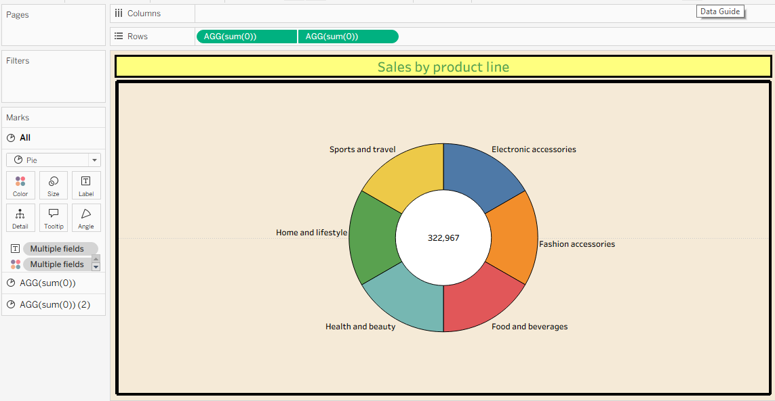

**2.Area Chart:**

* **column:** Date
* **Rows:** Sum(Total)

**In mark card: color :** product line**,** change chart type to Area.

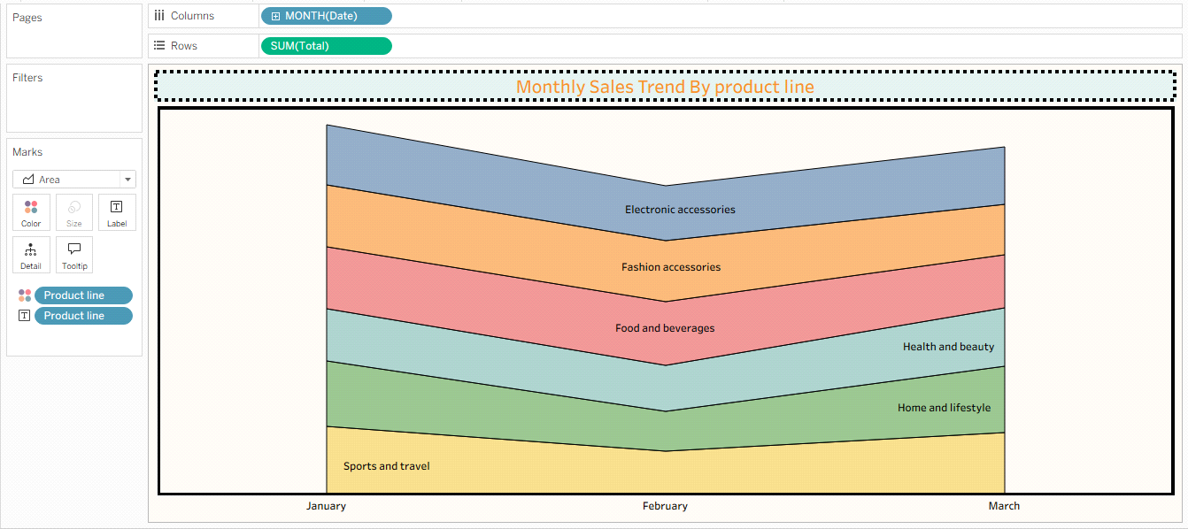

**3.Text Table:**

* **column:** Gender
* **Rows:** Branch

**In mark card:** Text: Total (make text bold, center aligned).

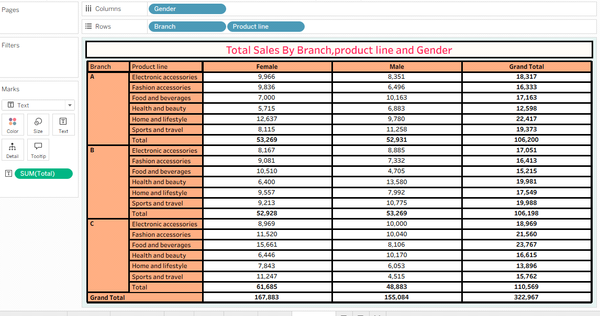

**4.Highlighted Table:**

* **column:** Product Line
* **Rows:** Branch and gender

**In mark card:** Drag and drop **AVG(Ratings)** to color and Text

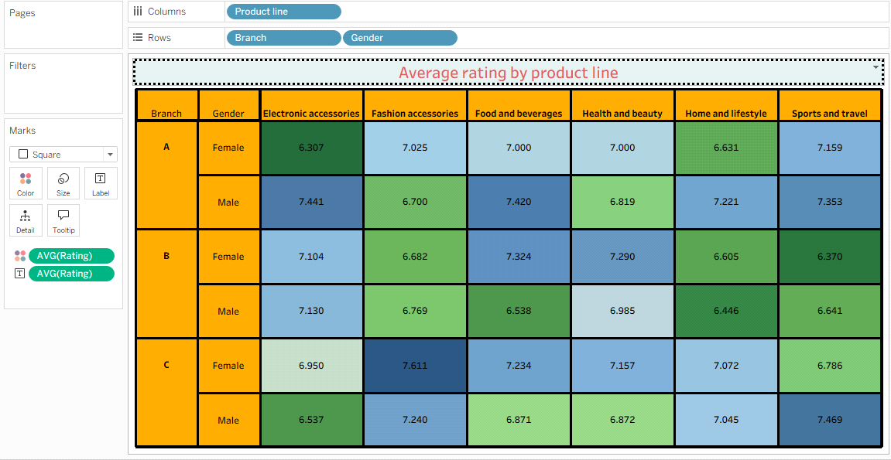

**5.WordCloud:**

* Drag product line -> **Label and color**
* Drag Total ->**Size**
* Marks card -> **select Text**

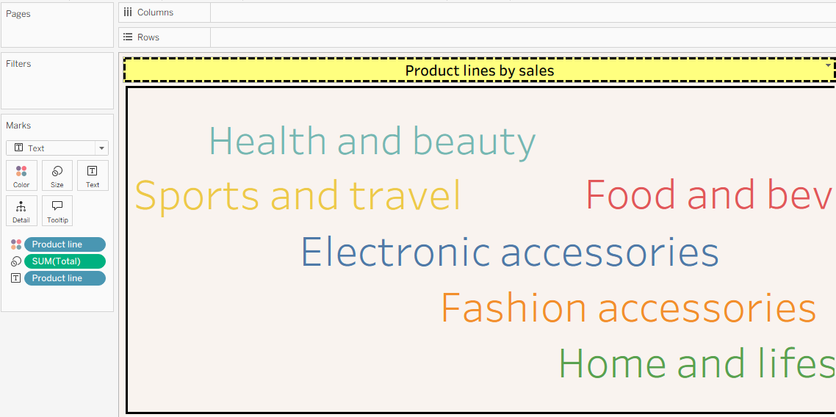

**6.Funnel Chart:**

* Drag and Drop SUM(Total) to Rows.
* Drag and Drop **Product Line** to both **Color** and **Label.**
* Drag and Drop **SUM(Total)** to both **Label** and **Size.**

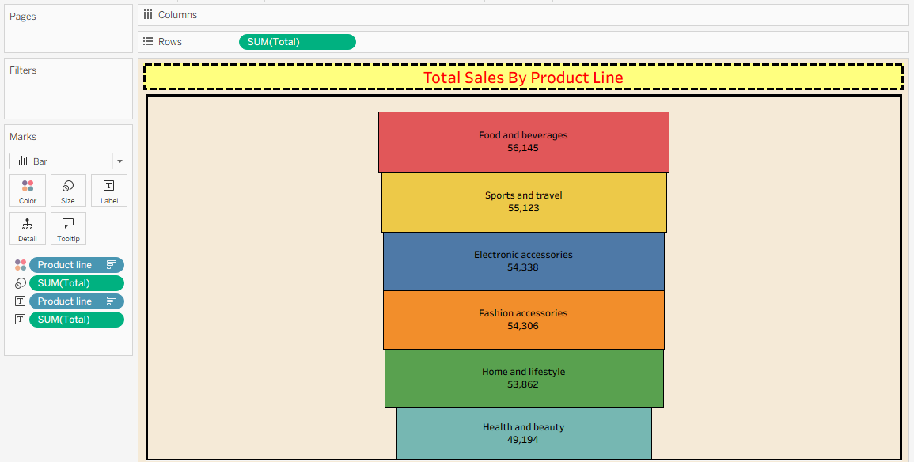

**5.WaterFall Chart:**

* Drag and Drop City to Columns.
* Drag and Drop Gross Income to Rows.
* Drag and Drop **City** to both **Color** and **Label.**
* Create calculation field ->**Running Income**
* Drag and Drop **SUM(Running Income)** to both **Label** and **Size.**

